Virtual machines and containers

Introduction
In the networking and computing world, virtual machines and containers are two powerful technologies that have revolutionized how software applications are managed and deployed. Both technologies provide a way to isolate and run multiple applications on a single physical host. However, they achieve this isolation differently, each with its benefits. In this reading, you will explore virtual machines and containers, learn their differences, tools to manage them, and how they can assist in networking and security testing.

Virtual machines and containers
A virtual machine, or virtual server is as its name suggests, a software system that works like an individual virtual computer. Using software like hypervisors, you can split a physical machine into multiple virtual machines that share the physical server resources like ram, storage, processing power and network. As indicated in the image below, these virtual machines have their own operating system and work totally independently from each other. Working in an isolated environment or sandboxed environment, VMs do not interfere with each other.
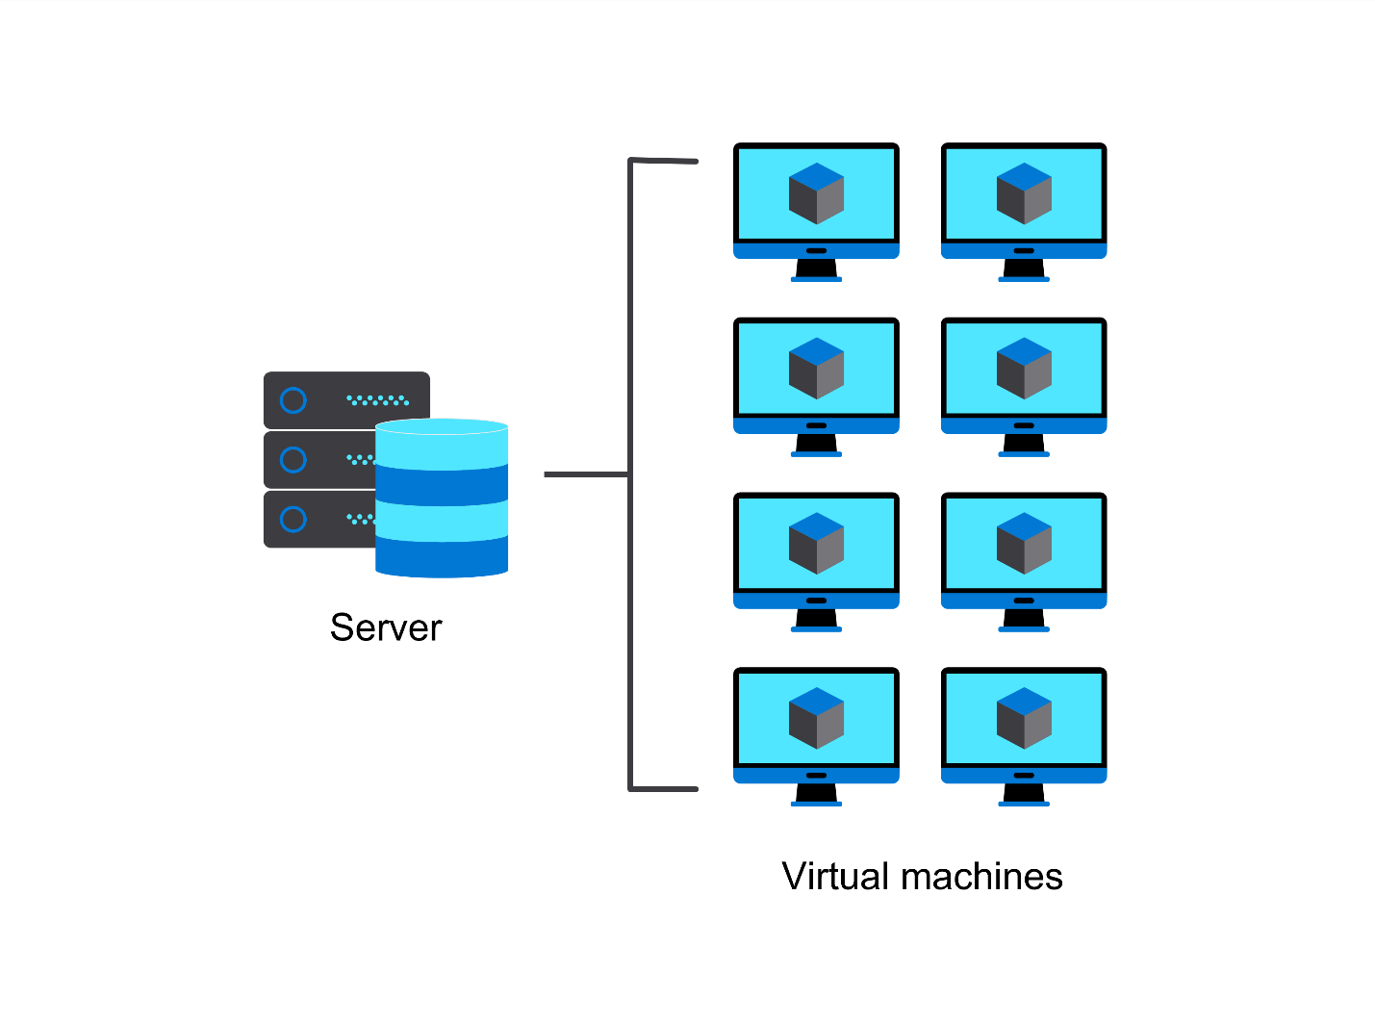
In contrast, a container is a lightweight software package that provides an isolated environment for running applications. As demonstrated in the image below, containers share the underlying operating system with the host machine, but each container has its own file system, networking, and application space. They are more lightweight and portable than VMs, making them popular for deploying and scaling applications in cloud environments.
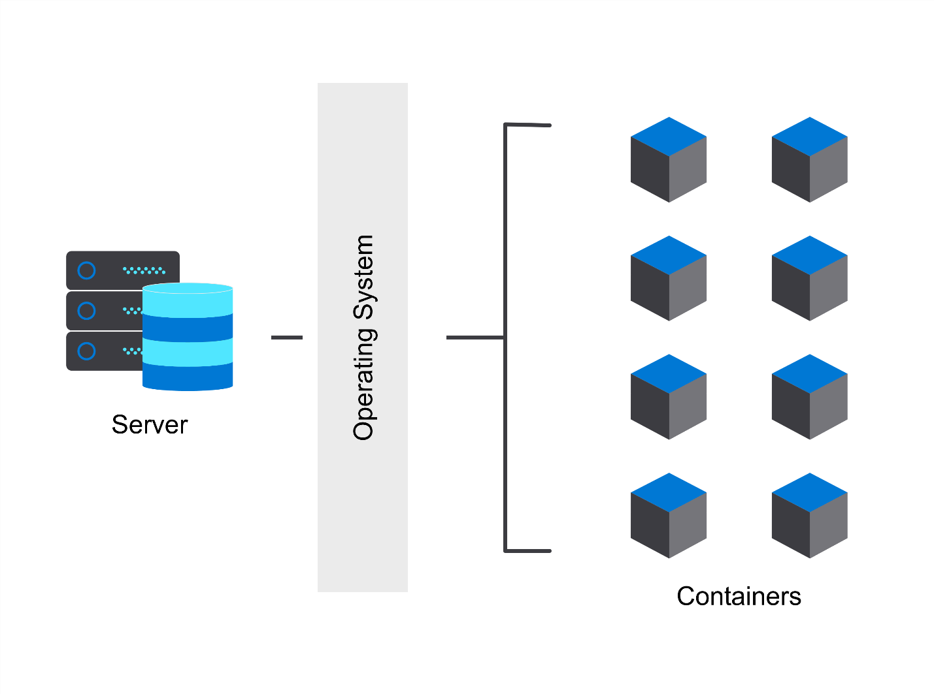
In virtualization, the host machine is the physical computer that runs the virtualization software, also known as the hypervisor. The hypervisor allows the host machine to create and manage one or more virtual machines or guest machines.
The image below demonstrates the difference between virtual machines and containers as explained above.
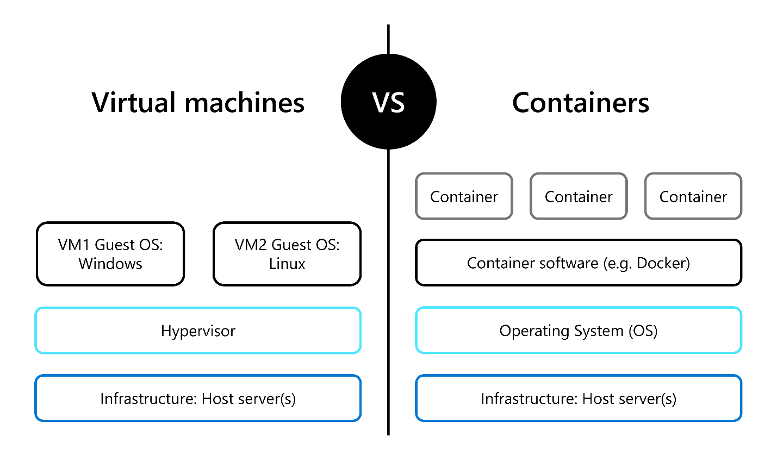

Tools for virtual machines and containers
Several tools are available to create virtual machines, such as VMware Workstation, VirtualBox, and Hyper-V. VMware Workstation is a popular virtual machine software that provides a paid virtualization solution for Windows and Linux. VirtualBox, on the other hand, is an open-source virtualization software that is available for Windows, macOS, and Linux. Hyper-V is a native virtualization software created by Microsoft for Windows that enables users to create and run multiple operating systems on a single host machine.
To create containers, Docker is a popular containerization platform that allows developers to build, ship, and run applications as containers. Kubernetes is an open-source software for automating container deployment, scaling, and management. This process is called container orchestration. Podman is another container engine that runs on Linux and can manage containers. These tools allow users to create and manage containers and orchestrate containerized applications in a distributed environment.

How virtual machines and containers can help in networking and security testing
Virtual machines and containers are powerful tools for networking professionals to simulate and experiment with virtual networks, infrastructure, and security tools in an isolated environment.
By creating virtual machines, you can simulate and experiment with different network configurations and protocols. Virtual machines can create a virtual network with multiple subnets, routers, switches, and servers and test the communication process between different devices. This is useful for testing different network configurations and protocols and ensuring your network is optimized for performance and security.
Virtualization can also simulate an entire infrastructure, including servers, databases, applications, and services. By creating multiple virtual machines and configuring them to work together, you can create a complete infrastructure that can be used for testing and development purposes. This is useful for testing new software releases, security patches, and upgrades in a controlled environment before deploying them to production.
Virtual machines and containers can also run network security tools in isolation. By running security tools in a virtual environment, you can isolate them from the host machine and other applications, reducing the risk of any damage and security risks exposed to the outside world. This is useful for testing the effectiveness of different security tools, such as intrusion detection systems (IDS) and web application firewalls (WAF), against various types of attacks.
Another way virtual machines can be used for security testing is by creating honeypots. A honeypot is a virtual machine or network intentionally designed to attract attackers. Creating a virtual machine that looks like a vulnerable system or service can attract attackers and gather information about their tactics and techniques. You can also simulate network attacks, such as denial-of-service attacks or malware infections and test your network's resilience against these threats.
Virtual machines and containers can be used to test how secure your own network is. To simulate network attacks, you can use tools like Kali Linux, a popular Linux distribution specifically designed for penetration testing and digital forensics. Kali Linux comes pre-loaded with a wide range of tools for network scanning, vulnerability analysis, password cracking, and other attack techniques. By running Kali Linux on a virtual machine, you can isolate it from the host machine and other applications, reducing the risk of interference or damage.

Conclusion
In this reading, you learned about the fascinating world of virtual machines and containers, two essential technologies that can be used in networking. You learned the main differences between these technologies and how they can be used to simulate a network infrastructure, test network security vulnerabilities, and increase the strength of a network.

Exemplar: Virtual network simulation

Introduction
In the Virtual network simulation exercise, you were given a scenario and asked to construct a virtual network diagram on Figma using provided icons. Review the steps in this exemplar as it provides a solution to this exercise.

Step 1 and 2
Start by creating a new file in Figma. Unzip the provided folder with the icons and add the icons to your Figma file.
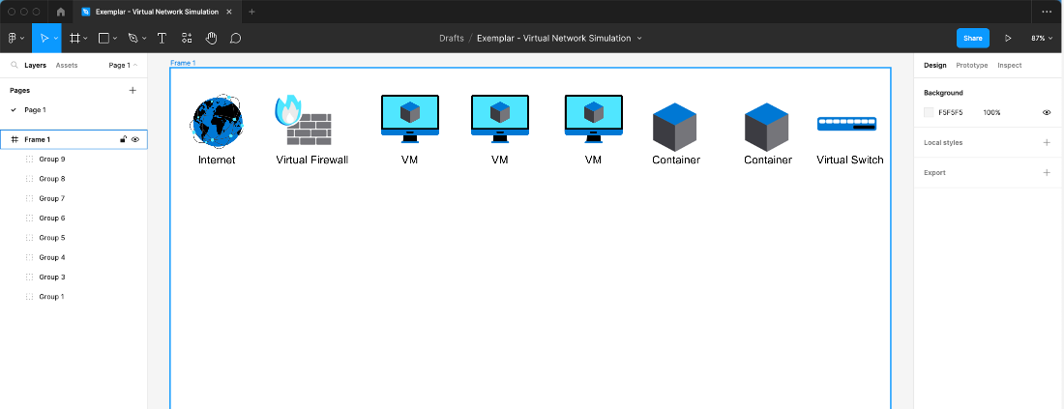

Step 3
Draw a rectangle by pressing the R key and label it as physical server. You can press the T key to type text.
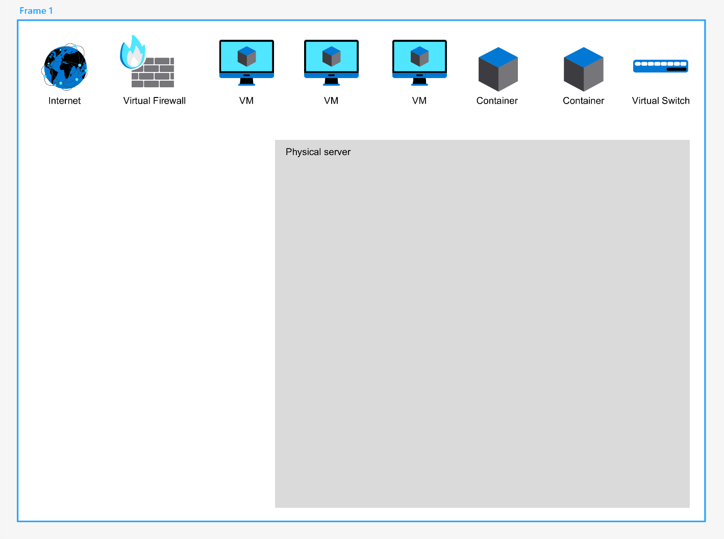

Step 4
Take two VM icons and place them inside the rectangle.
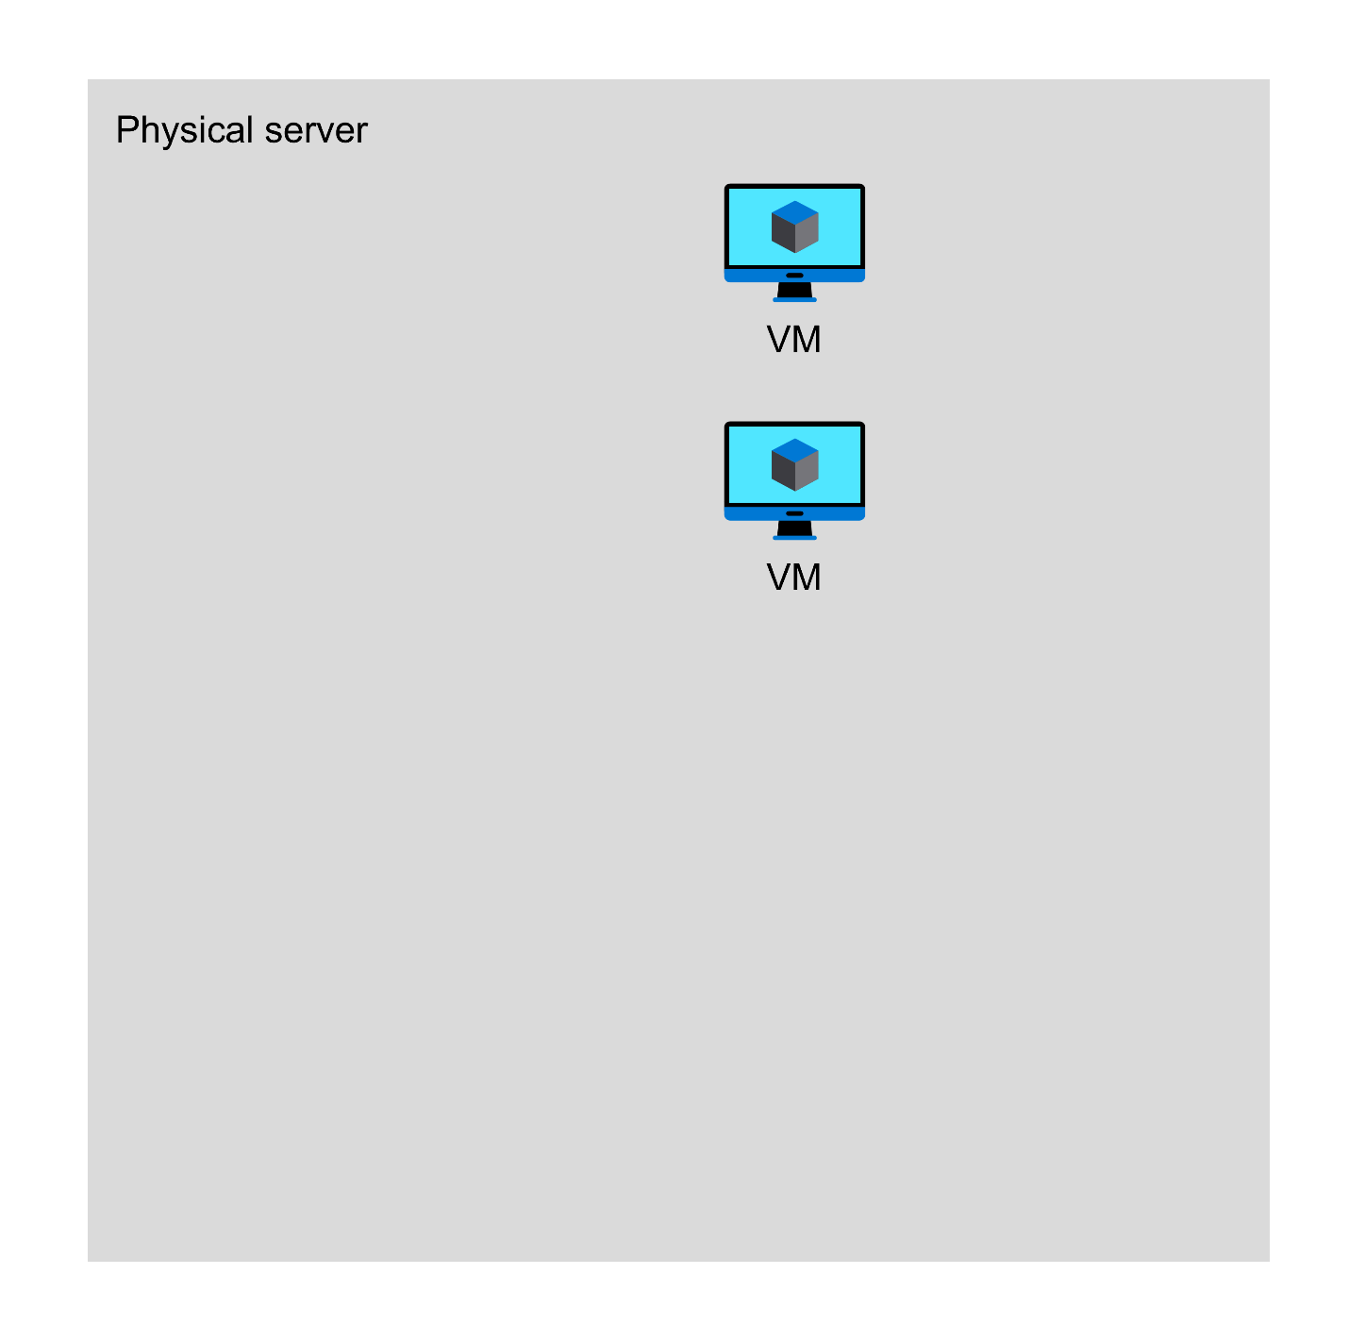

Step 5
Take another VM and place it inside the rectangle but a farther away from the first two.
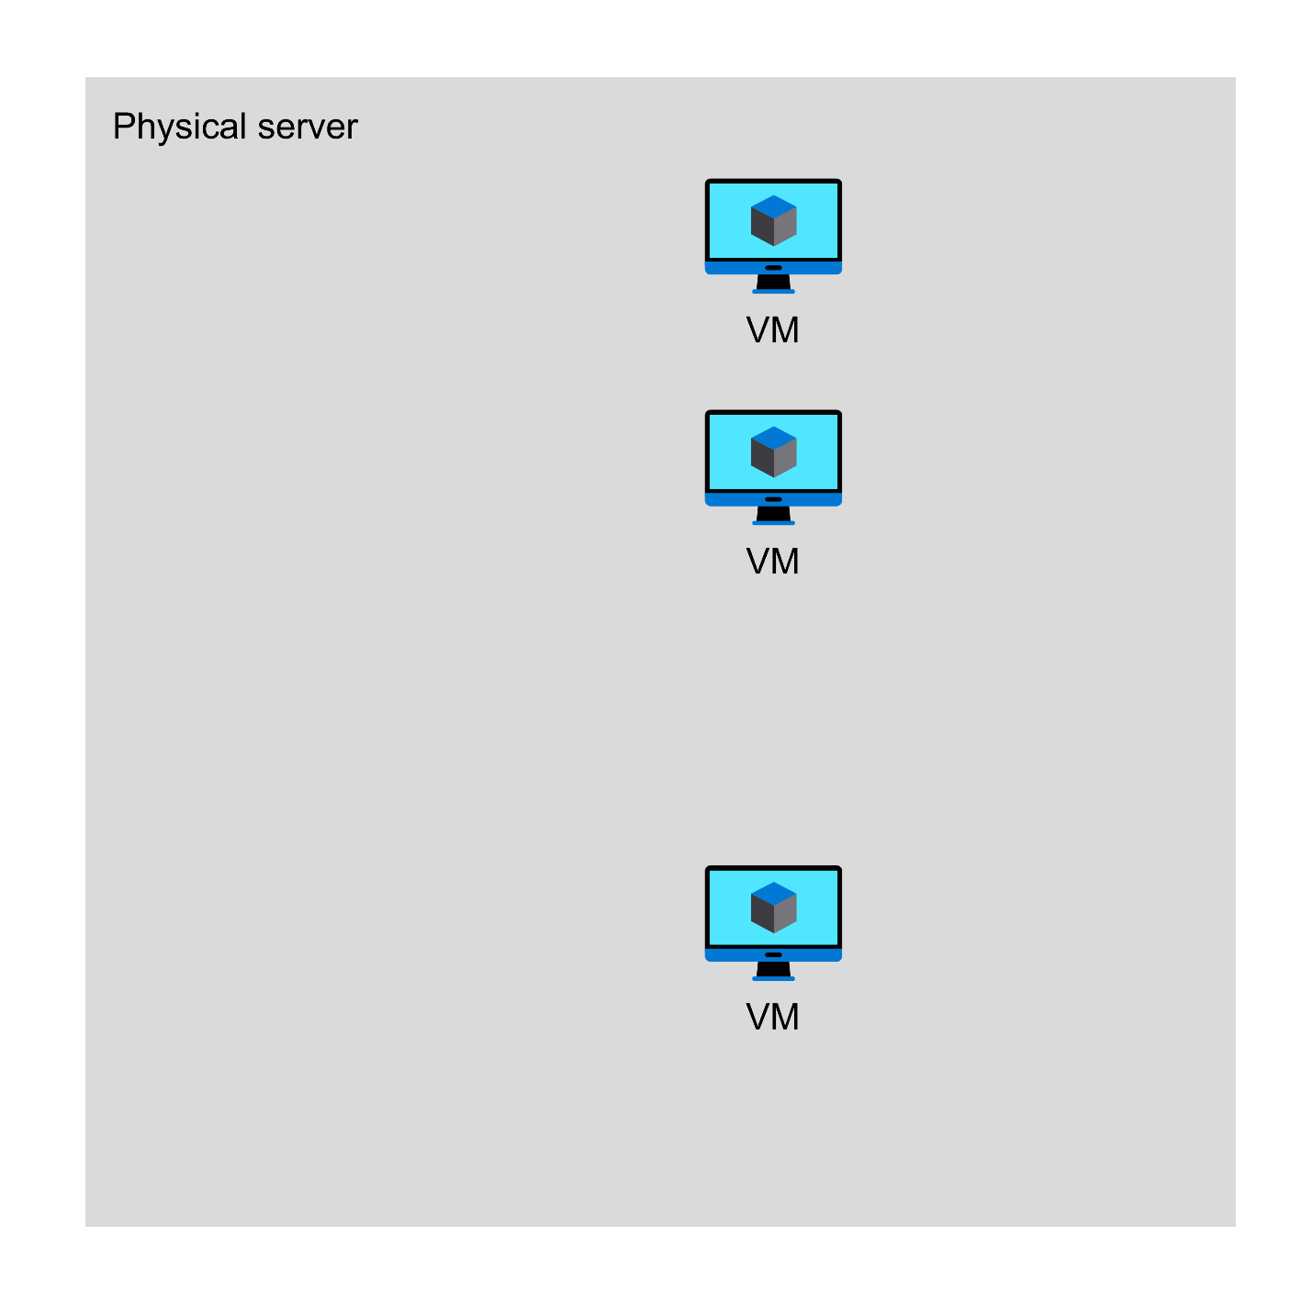

Step 6
Place two containers close to this third VM icon and connect them with lines to this VM, because they are hosted inside it. You can press the L key to draw a line on Figma.
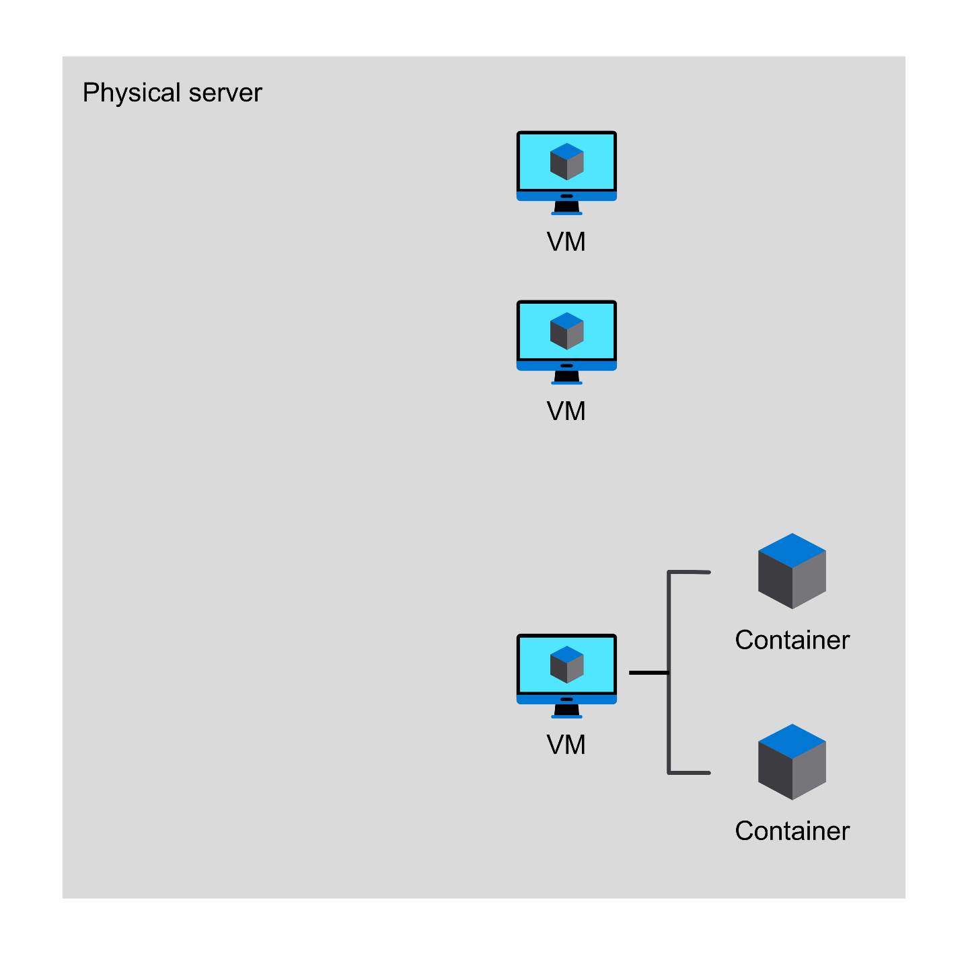

Step 7
Place that firewall icon inside the rectangle. Connect the firewall with the three VPNs.
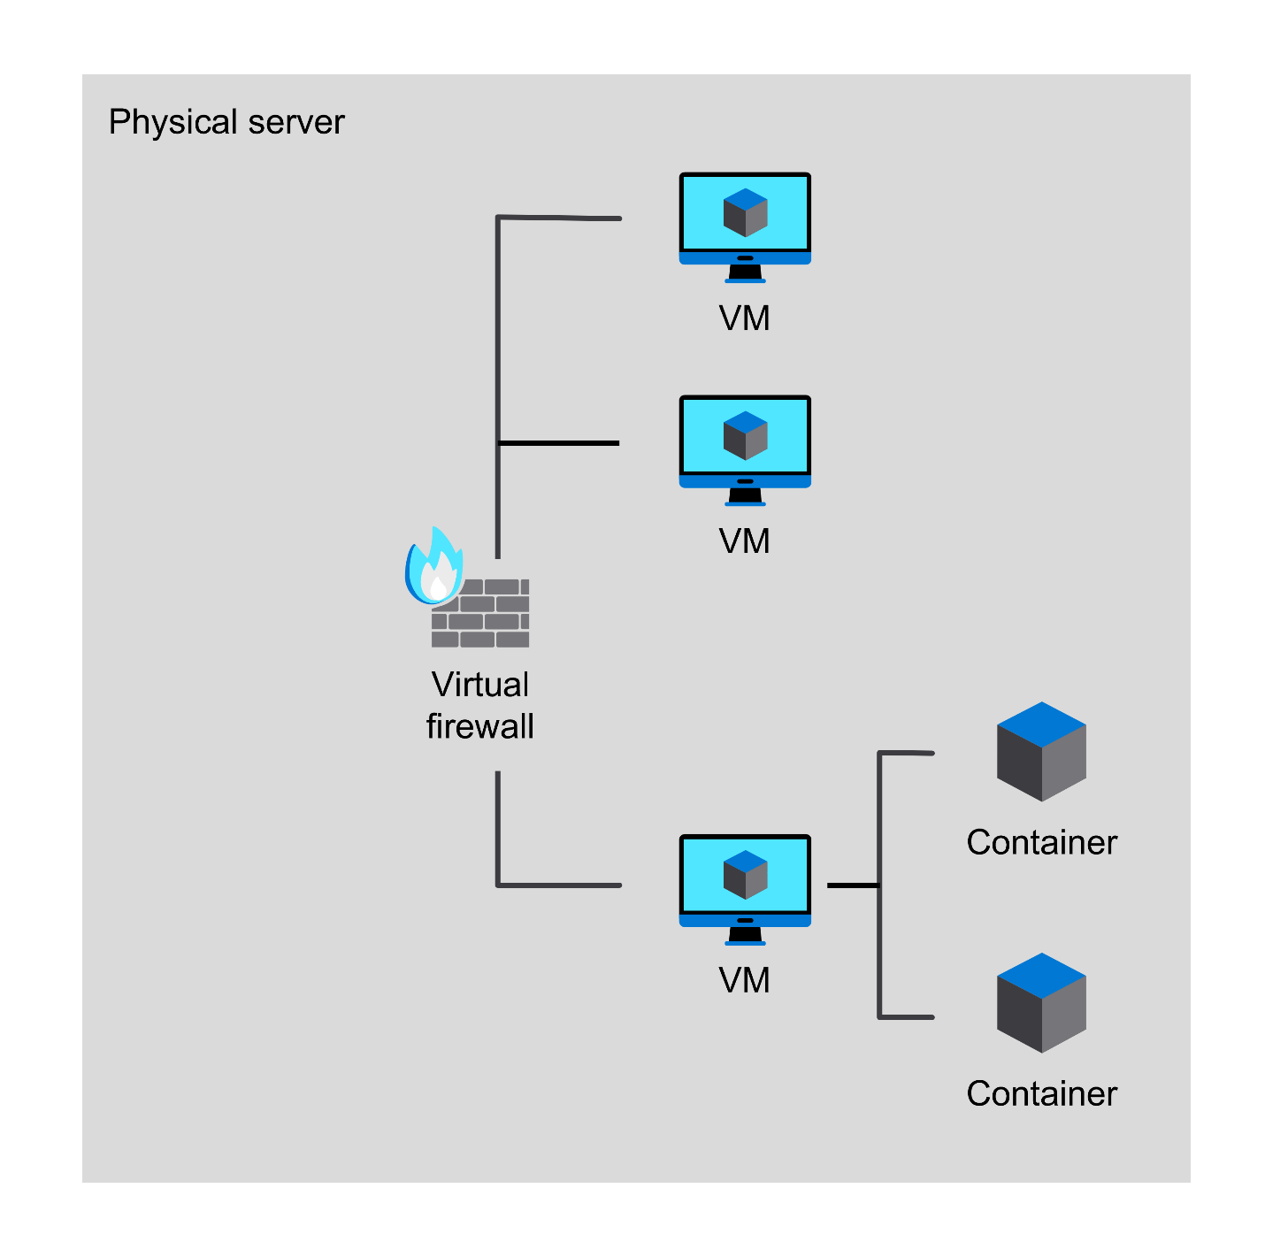

Step 8
Place a virtual switch inside this rectangle. Connect the virtual switch to the firewall.
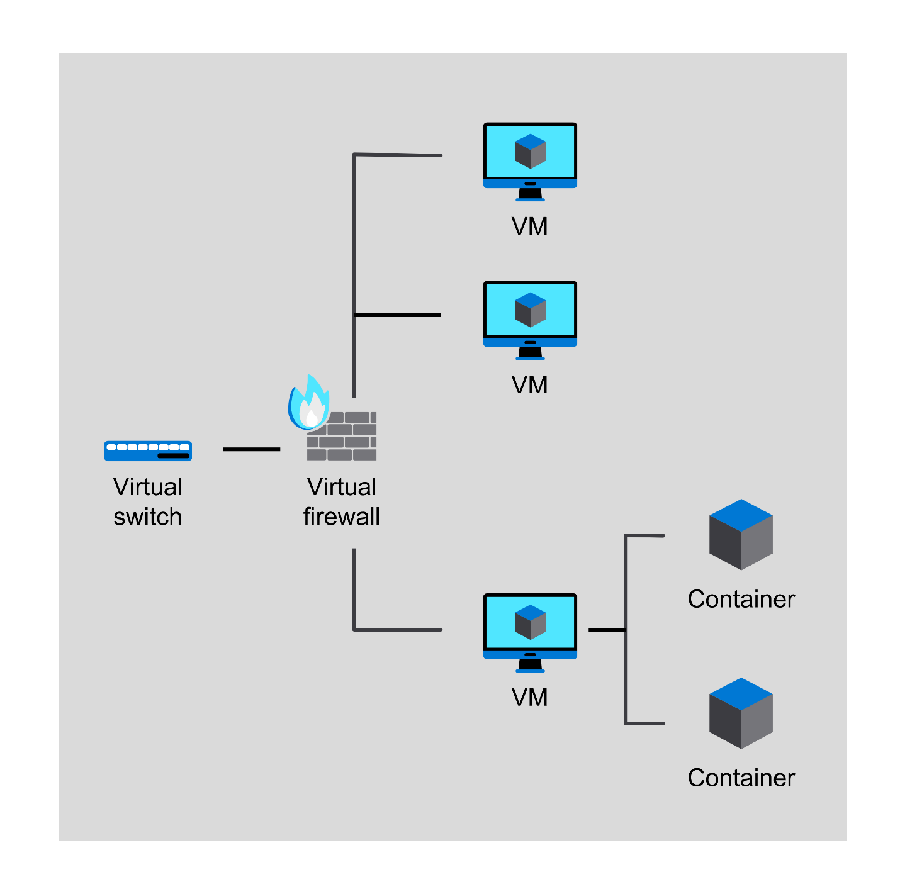

Step 9
Place the internet icon on the canvas and connect it to the physical server that is represented by the rectangle.
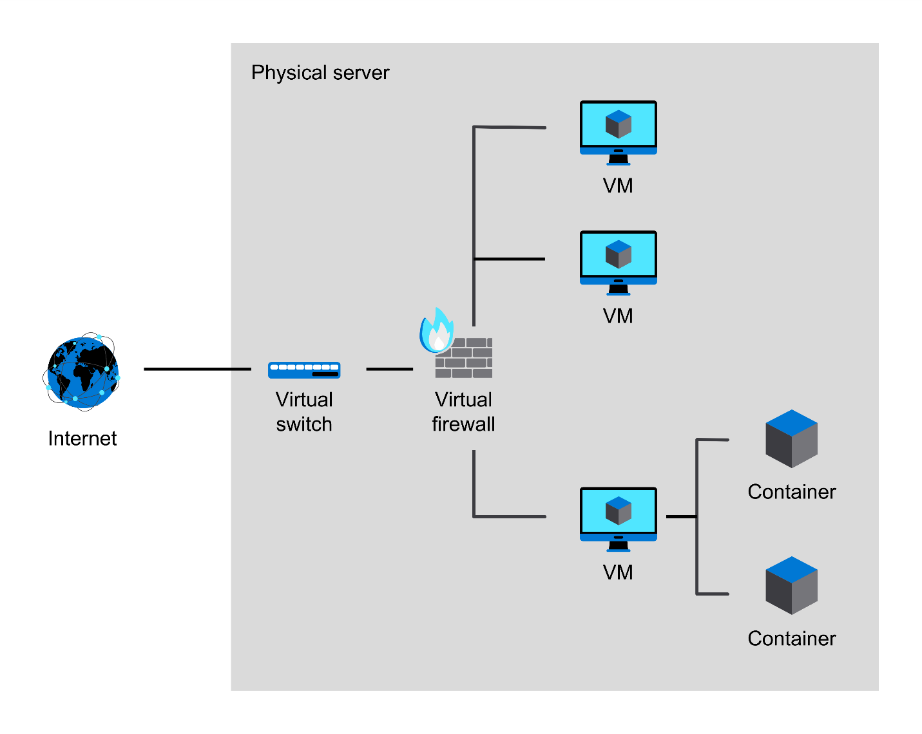

Conclusion
By completing this exercise, you practiced designing a virtual network that incorporates various components such as switches, routers, firewalls, servers, and VPN connections. This hands-on experience will help you understand how these components interact and work together to create a secure and efficient network infrastructure for a small company with remote workers.

